Ex.No : 4 | Configuring Cloudsim and simulating cloud scenarios
27.02.2021 | Configuring Cloudsim and simulating cloud scenarios

Aim
To simulate the scenarios in cloud using cloudsim and common math libraries.
Procedure
- Create a new Java project in the cloudsim directory.
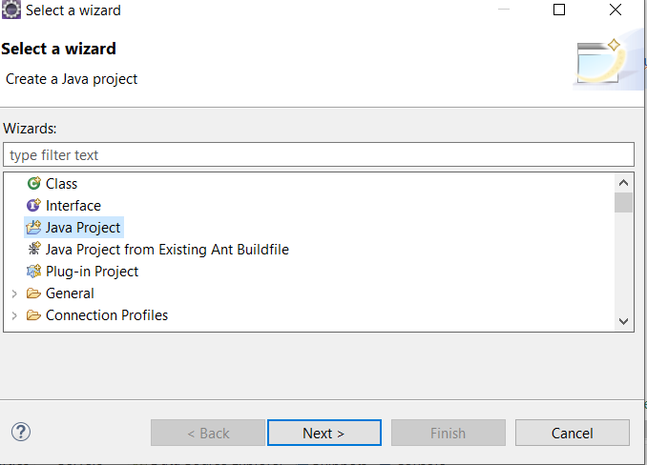
- Give a suitable project name and select the location as same as the cloudsim location.
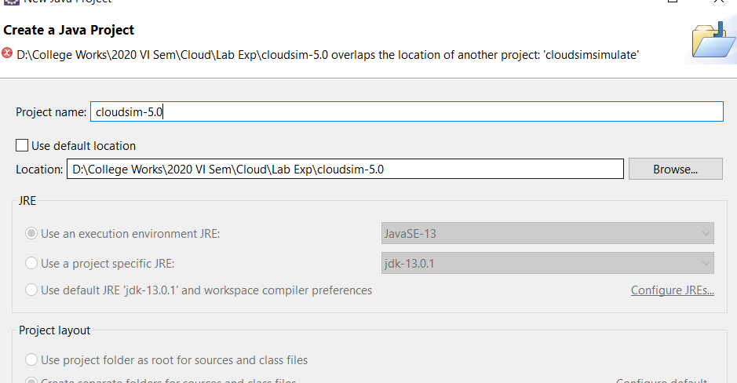
- Go to properties and navigate to module path.
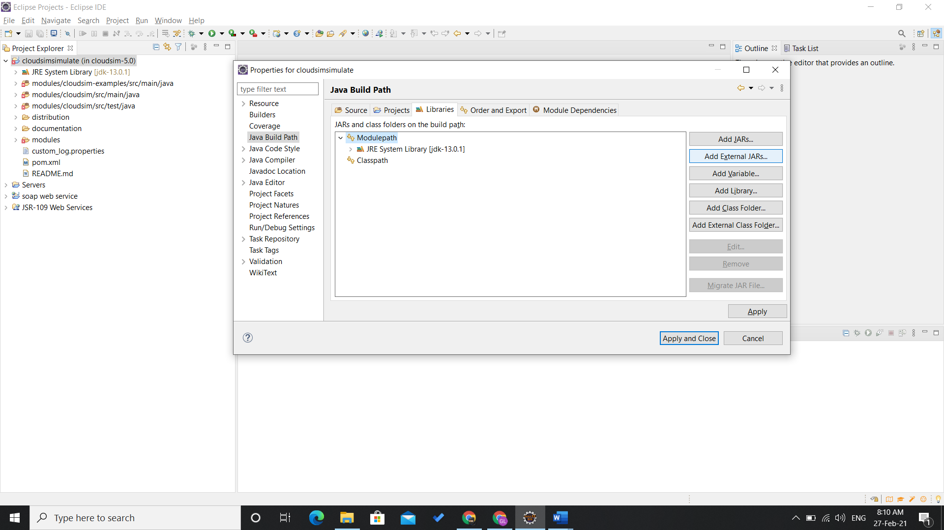
- Add common math jar files.
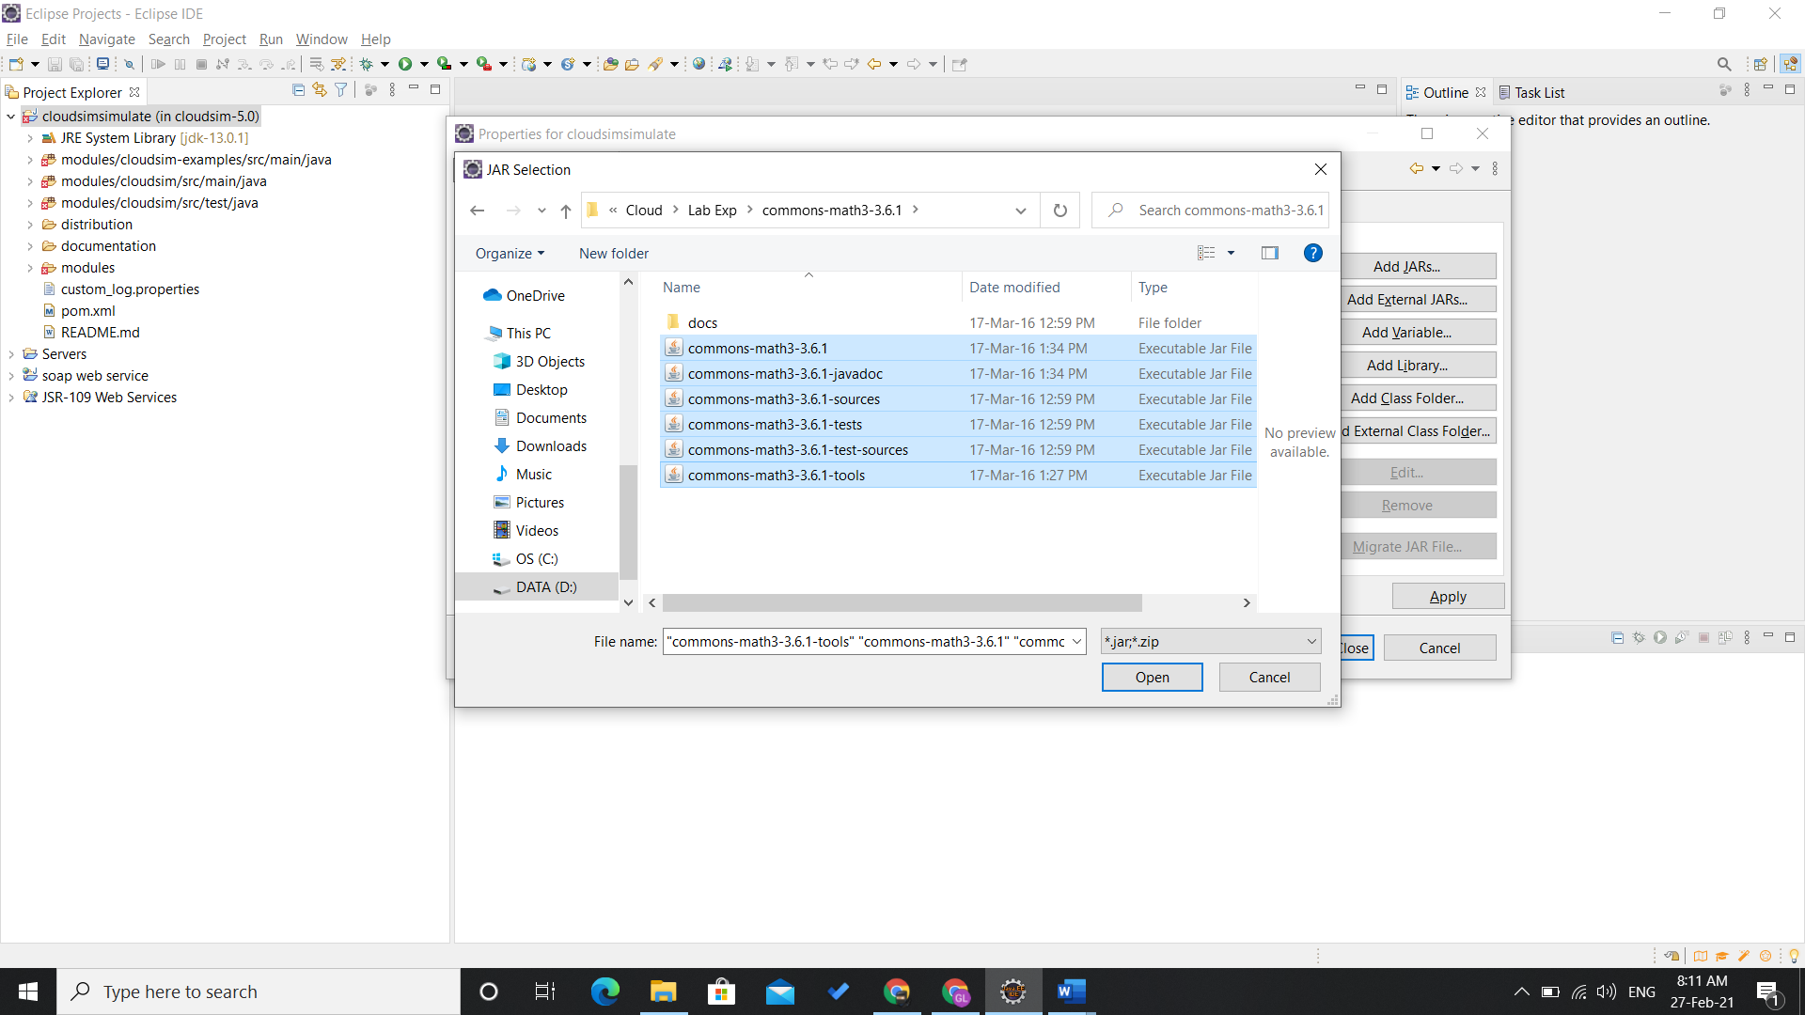

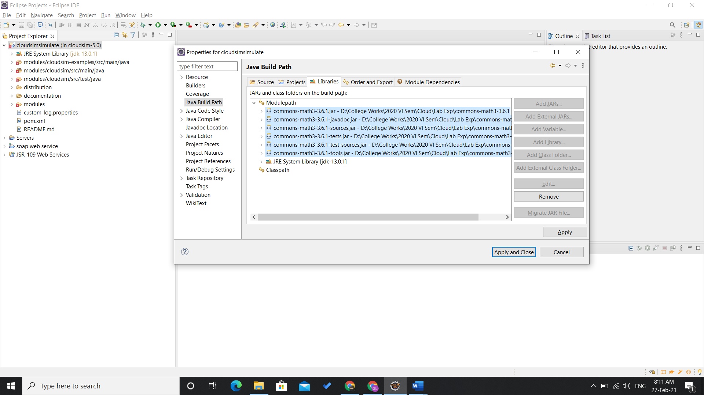
- The jar files are referenced.
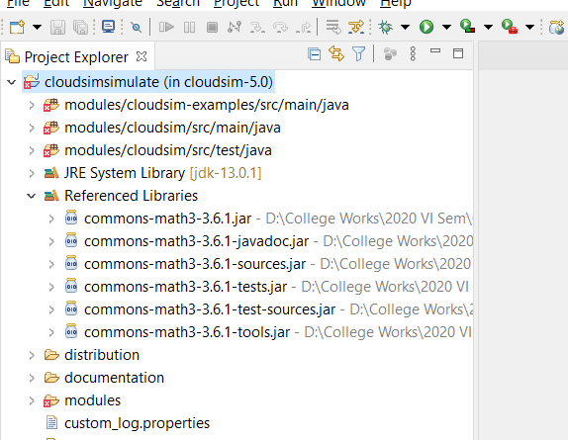

- Execute the example program under cloudsim example package.
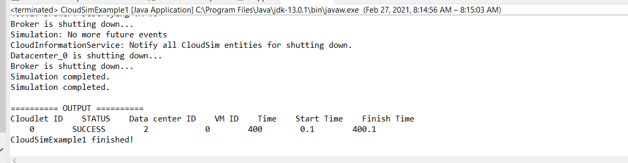
Explanation Program 1:
- We create two list to store cloudlets and vms.
- Initialize cloudsim package with parameters like number of users, date and time, events.
- Create atleast one datacenter to start the simulation. Datacenter class provides with the method createDatacenter() to do this.
- Next is to create a broker and a vm to the cloud sim. DatacenterBroker class provides with the method createBroker() to do this. Initialize a vm with Vm class and add to the vm list.
- Give the set of vms to the broker by using submitVmList().
- Create utilization model with UtilizationModel class and initialize cloudlet by creating an object for the Cloudlet class.
- Set vmId and userId for the cloudlet using setUserId() and setVmId() methods. Submit the cloudlet to the broker using submitCloudletList().
- Start the simulation using startSimulation() method.
Explanation Program 2:
- Follow the steps as mentioned in the above program upto creation of vm.
- Add another vm by incrementing the vmId + 1;
- Submit the vmList and get the cloudlets ready.
- Here submit each cloudlet to unique vms by bindCloudletToVm() method.
- Print the cloudlets added using getCloudletReceivedList() method.
- Start the simulation using startSimulation() and stopSimulation().
- The results will be printed.

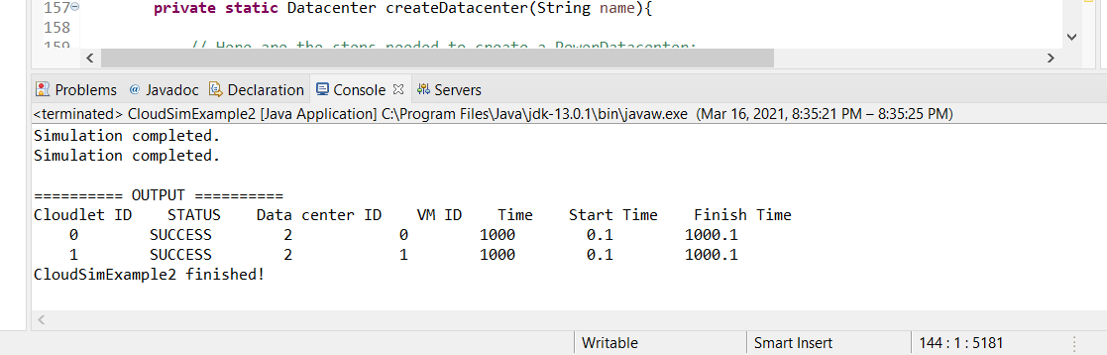

Result
Thus, the simulation of cloudsim is analyzed and the result is obtained.

